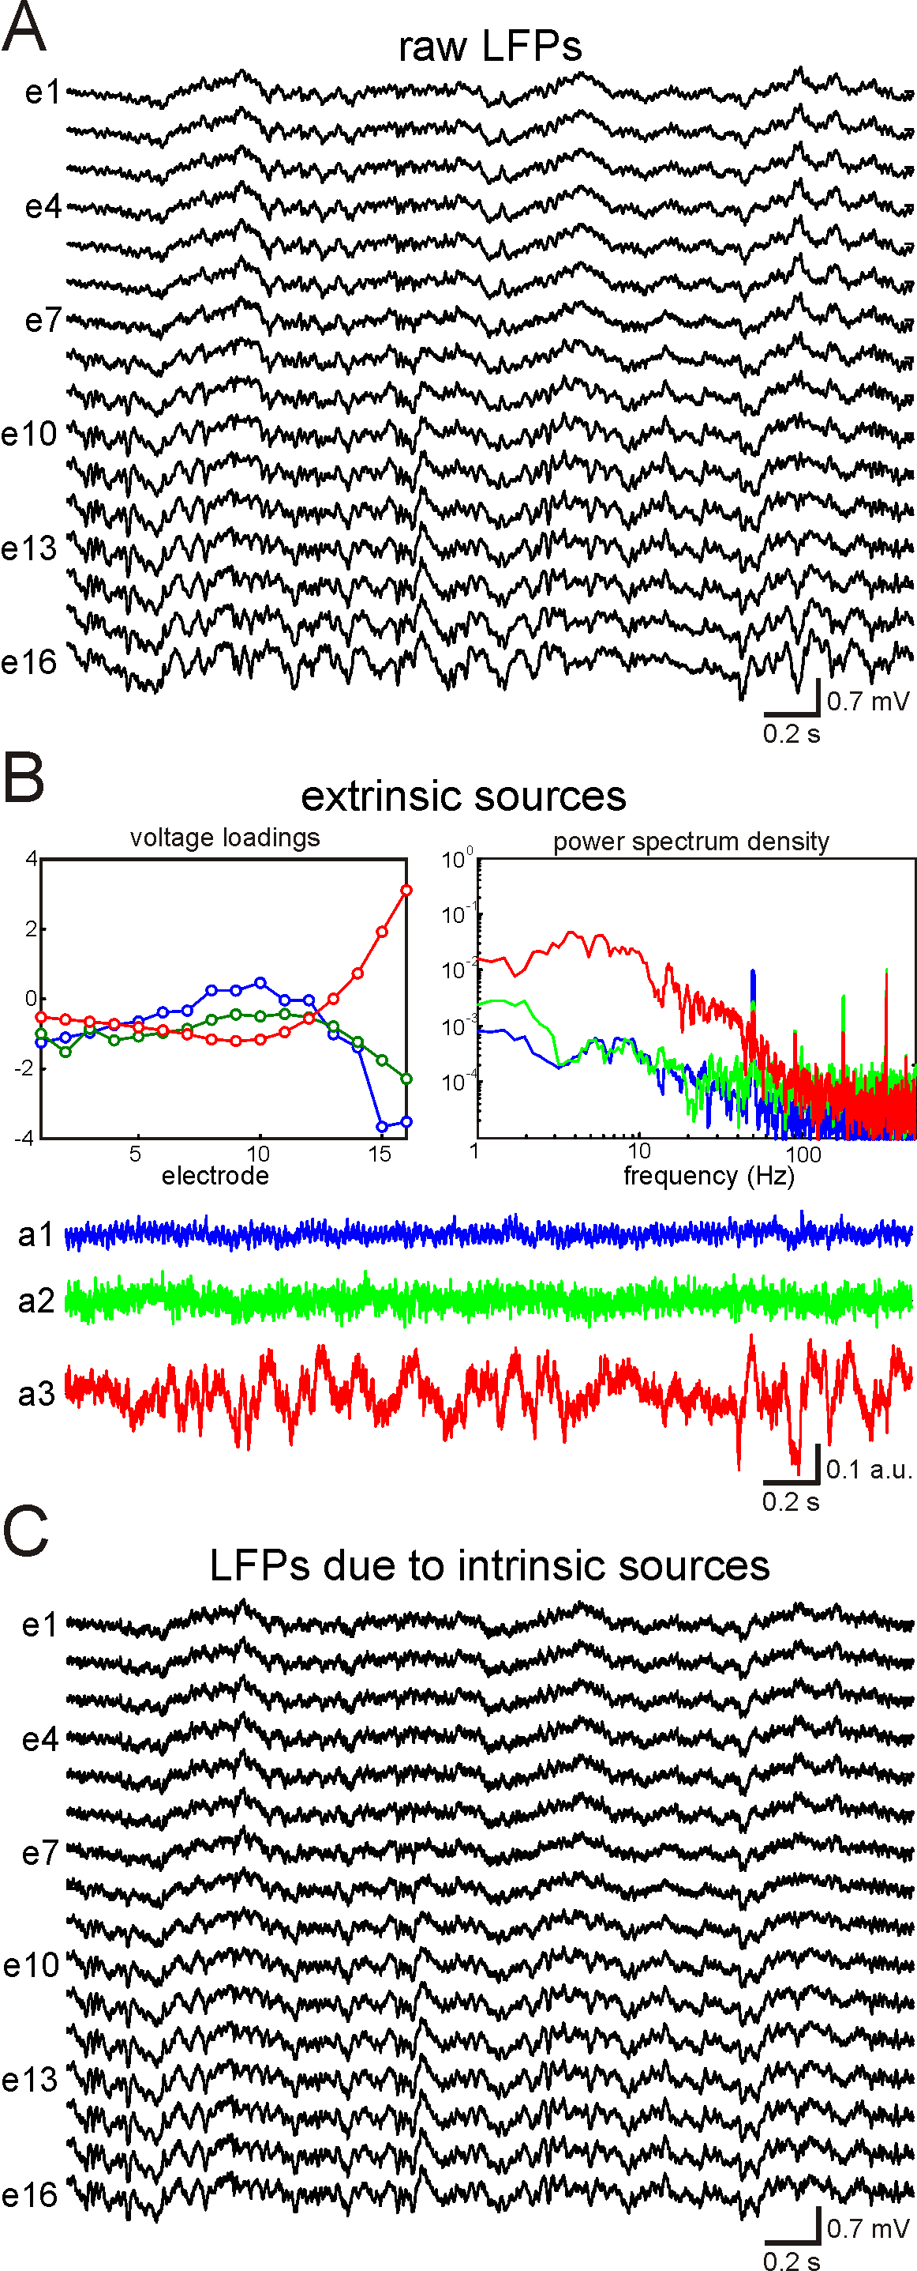
sFig. 1: Suppressing extrinsic LFP sources in CA1. A) Original raw LFPs recorded along the main CA1 axis. Electrodes from e1 to e16 cover completely the CA1 along the pyramidal neuron axis. Strong oscillations progessively increasing their amplitude towards the bottom of CA1 (e16) can be appreciated. This suggests their extrinsic origin. B) Extrinsic sources. Three voltage loadings U1-U3 (left panel) and "artificial" sources a1-a3 (bottom panel) corresponding to the three constraints (Eq. 2 in the main text). Right panel shows their Fourier spectra. Particularly, the footprint of the strongest (red) source can be easily identified in the raw LFPs. C) Clean LFPs obtained by subtracting the "artificial" sources (Eq. 3 in the main text).

